数字图像处理实验报告

班级： 智能专研 25

姓名： 王耀彬

学号： 2025354100103

目录

实验项目二：人体部件检测系统 1

**前言** 1

**1 基础人体部件检测** 1

**1.1 实验原理** 1

**1.1.1 Haar特征与级联分类器** 1

**1.2 系统架构设计与实现** 1

**1.2.1 全局面部检测** 2

**1.2.2 局部器官检测（ROI优化）** 3

**1.2.3 瞳孔检测（基于形状分析）** 5

**2 其他实现** 6

**2.1 AR面具系统** 6

**2.2 几何约束过滤器** 8

**2.3 隐私马赛克盾** 9

**3 附录** 11

**3.1 Baseline.py** 11

**3.2 ar_mask.py** 19

**3.3 privacy_mosaic.py** 24

实验项目二：人体部件检测系统

**前言**

本次实验旨在构建一个实时人体部件检测系统，能够从摄像头视频流中检测人脸及其面部器官（眼睛、鼻子、嘴巴、耳朵、瞳孔），并在画面中进行可视化标注。

系统采用两种核心技术。

·瞳孔：基于形状分析的轮廓检测

·人脸、眼睛、鼻子、嘴巴、耳朵：Haar级联分类器

**1 基础人体部件检测**

**1.1 实验原理**

**1.1.1 Haar特征与级联分类器**

Haar特征是Viola-Jones人脸检测算法的基础，其核心思想是：

1.Haar特征：使用简单的矩形特征（边缘特征、线特征、中心环绕特征）描述图像局部区域。

2.积分图加速：通过积分图实现 $O(1)$ 时间复杂度的特征计算

3.AdaBoost级联：多个弱分类器级联形成强分类器，逐层过滤非人脸区域

其具体算法原理如下，矩形特征描述：

$$\begin{aligned}f_{Haar}=\sum_{i∈white}{I\left(i\right)}-\sum_{j∈black}{I\left(j\right)}\#\left(1-1\right)\end{aligned}$$

其中 $I(i)$ 表示像素 $i$ 的灰度值。

积分图实现 $O\left(1\right)$ 时间复杂度的特征计算：

$$\begin{aligned}II\left(x,y\right)=\sum_{x^{'}≤x,y^{'}≤y}{I\left(x^{'},y^{'}\right)}\#\left(1-2\right)\end{aligned}$$

任意矩形区域的像素和可通过4次查表计算：

$$\begin{aligned}\sum_{\left(x,y\right)∈R}{I\left(x,y\right)}=II\left(D\right)-II\left(B\right)-II\left(C\right)+II\left(A\right)\#\left(1-3\right)\end{aligned}$$

**1.2 系统架构设计与实现**

完整代码见附录‘baseline.py’

整个检测系统封装在FaceDetector类中，采用模块化设计：

|  |
| --- |
| class FaceDetector:  def __init__(self):  # 加载所有级联分类器  self.cascades = {}  for name, path in CASCADE_PATHS.items():  self.cascades[name] = cv2.CascadeClassifier(path) |

系统共加载6个Haar级联分类器文件：

|  |  |
| --- | --- |
| 分类器文件 | 用途 |
| haarcascade_frontalface_alt.xml | 正脸 |
| haarcascade_eye.xml | 眼睛 |
| haarcascade_mcs_nose.xm’ | 鼻子 |
| haarcascade_mcs_mouth.xml | 嘴巴 |
| haarcascade_mcs_leftear.xml | 左耳 |
| haarcascade_mcs_rightear.xml | 右耳 |

**1.2.1 全局面部检测**

关键技术实现：

|  |
| --- |
| def detect_face(self, frame, gray=None):  if gray is None:  gray = cv2.cvtColor(frame, cv2.COLOR_BGR2GRAY)  faces = self.cascades["face"].detectMultiScale(  gray,  scaleFactor=1.1, # 图像金字塔缩放比例  minNeighbors=5, # 候选框合并阈值  minSize=(30, 30), # 最小检测尺寸  flags=cv2.CASCADE_SCALE_IMAGE  )  return faces |

关键参数解析：

·scaleFactor=1.1：每次图像缩小为原来的 $\frac{1}{1.1}≈90.9\%$，用于多尺度检测

·minNeighbors=5：只有当某区域被检测到 $≥5$ 次时才认定为人脸，有效减少误检

·minSize=(30,30)：过滤小于 $30×30$ 像素的候选区域

实现效果如下图：

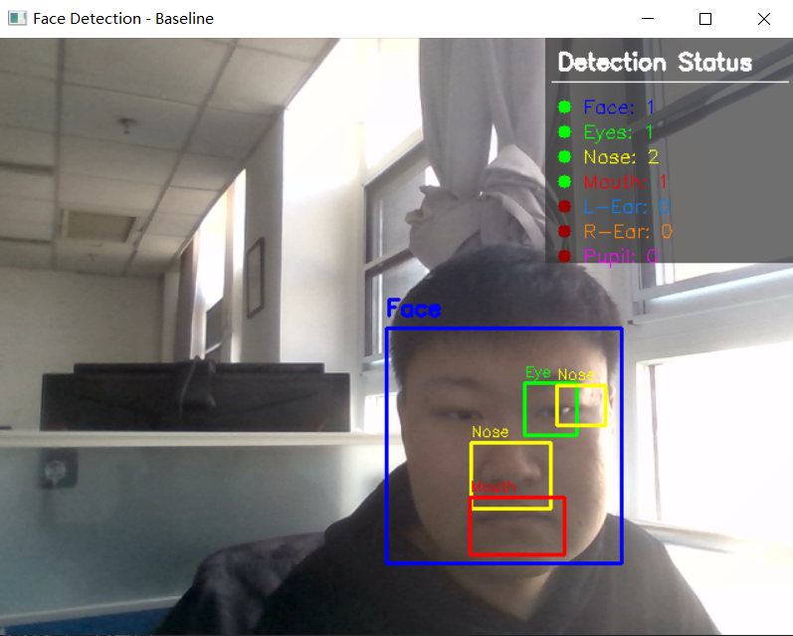

**1.2.2 局部器官检测（ROI优化）**

直接在全图搜索器官会导致：

·计算开销大：搜索范围过大

·误检率高：背景纹理可能被误检为器官

解决方案：采用ROI（Region of Interest）约束，仅在人脸区域内搜索器官。

特别的，左右耳需要使用不同的分类器分别检测。

问题发现：在实际测试中发现，当用户呈现侧脸时：

1. 正脸分类器无法检测到人脸（Face: 0）

2. 耳朵检测依赖于人脸ROI，导致耳朵也无法检测

解决方案：实现全局耳朵检测作为备选方案。

实现效果如下图：

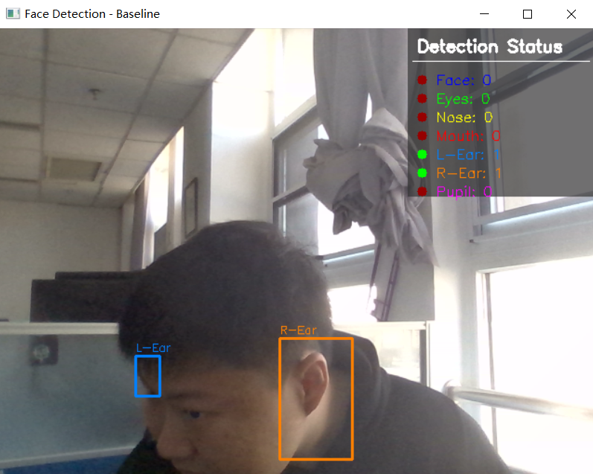

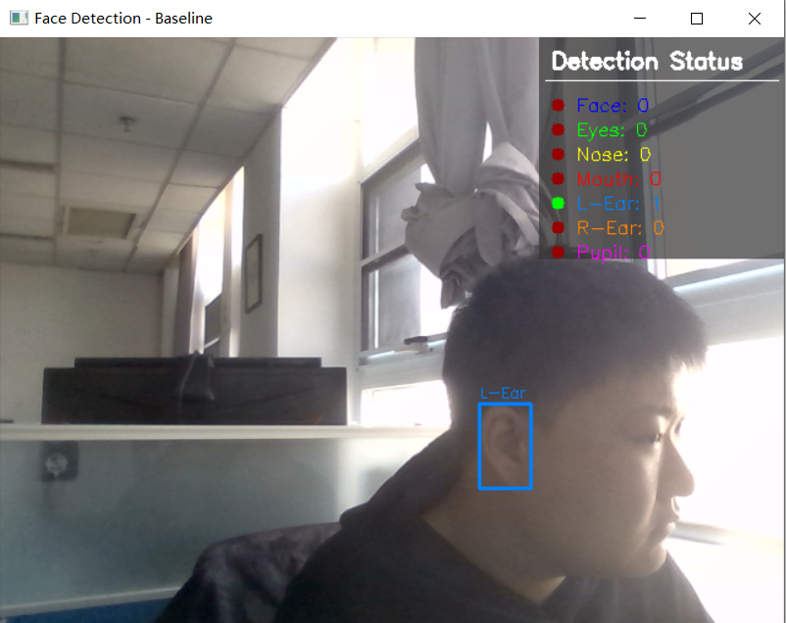

**1.2.3 瞳孔检测（基于形状分析）**

与其他器官不同，瞳孔检测不使用级联分类器，而是采用基于形状分析的自定义算法：

**输入眼睛ROI → 灰度化 → 高斯模糊 → 图像反相 → 二值化 → 轮廓查找 → 几何筛选 → 输出瞳孔位置**

瞳孔是眼睛中最暗的区域，直接检测黑色区域较困难。通过**图像反相**操作：

$$\begin{aligned}Iinv\left(x,y\right)=255-I\left(x,y\right)\#\left(1-4\right)\end{aligned}$$

使得瞳孔从暗区变为高亮区域，便于后续阈值分割。

轮廓查找后可能得到多个候选区域，需要通过几何特征筛选出瞳孔：

1. 面积约束：瞳孔面积应占眼睛区域的

2. 圆形度约束：瞳孔接近圆形，其中圆形度计算公式如下，完美圆形的圆形度为1。

$$\begin{aligned}Circularity=\frac{4π⋅Area}{Perimeter^{2}}\#\left(1-5\right)\end{aligned}$$

统在画面右上角显示实时检测状态面板，包含所有部位的检测计数，红色代表未检测到，绿色的代表检测到。

瞳孔检测见下图。

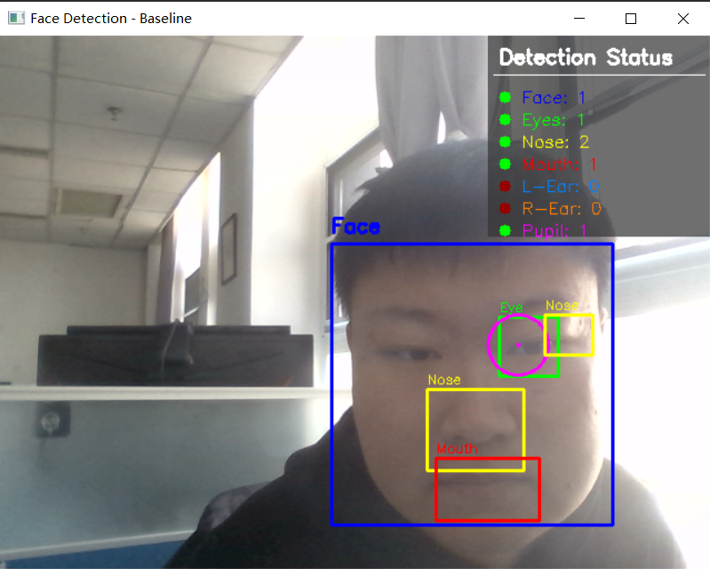

**2 其他实现**

**2.1 AR面具系统**

实现增强现实（AR）面具佩戴效果，将虚拟面具图像无缝融合到检测到的人脸区域。

核心技术：掩膜（Mask）生成与位运算（Bitwise Operations）

面具融合采用经典的位运算方法，流程如下：

**1. 缩放面具 → 2. 生成二值掩膜 → 3. 逆掩膜抠背景 → 4. 提取面具前景 → 5. 融合**

关键代码实现：

|  |
| --- |
| # 1. 生成二值掩膜（面具非白色区域）  mask_gray = cv2.cvtColor(mask_bgr, cv2.COLOR_BGR2GRAY)  _, mask_binary = cv2.threshold(mask_gray, 240, 255, cv2.THRESH_BINARY_INV)  # 2. 生成逆掩膜  mask_inv = cv2.bitwise_not(mask_binary)  # 3. 在人脸ROI中抠出面具形状的空洞  roi_bg = cv2.bitwise_and(roi, roi, mask=mask_inv)  # 4. 提取面具的前景部分  mask_fg = cv2.bitwise_and(mask_bgr, mask_bgr, mask=mask_binary)  # 5. 融合背景与前景  result = cv2.add(roi_bg, mask_fg) |

实际测试中发现两个问题：

1. 面具太靠下：Haar检测框偏下

2. 覆盖不完整：人脸较大时面具无法覆盖整个脸部

解决方案：添加缩放和偏移参数scale、y_offset_ratio

最终效果如下。

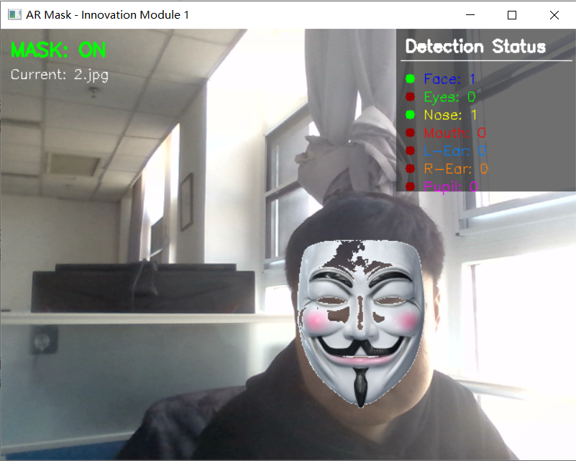

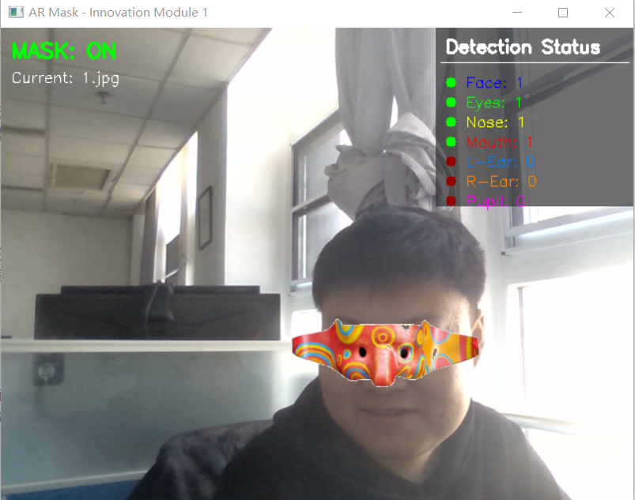

**2.2 几何约束过滤器**

Haar级联分类器存在误检问题，例如将背景纹理误识别为嘴巴。通过引入解剖学常识，对检测结果进行逻辑校验，可有效降低误检率。

核心思想：器官位置应符合人脸解剖学规律

约束规则：

|  |  |  |
| --- | --- | --- |
| **器官** | **约束条件** | **范围（%）** |
| **眼睛** | 在人脸上部 | 10-55 |
| **鼻子** | 在人脸中部 | 25-75 |
| **嘴巴** | 在人脸下部 | 50-95 |

效果如下：

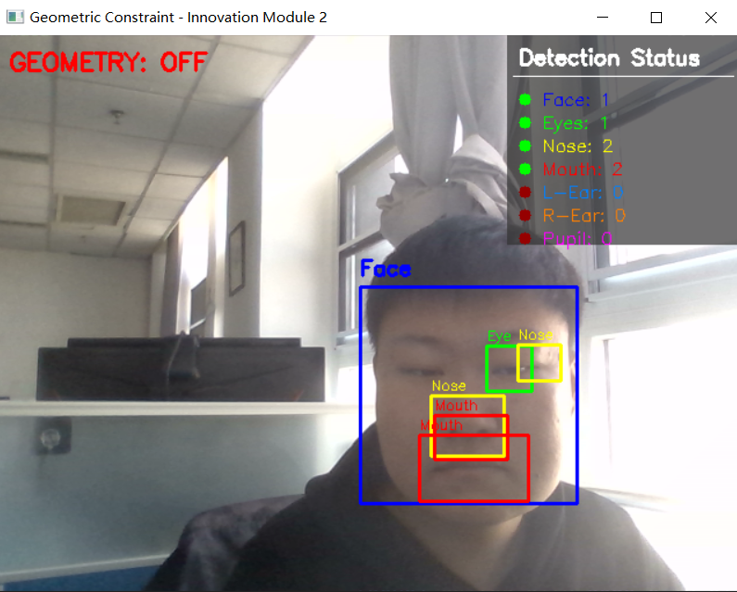

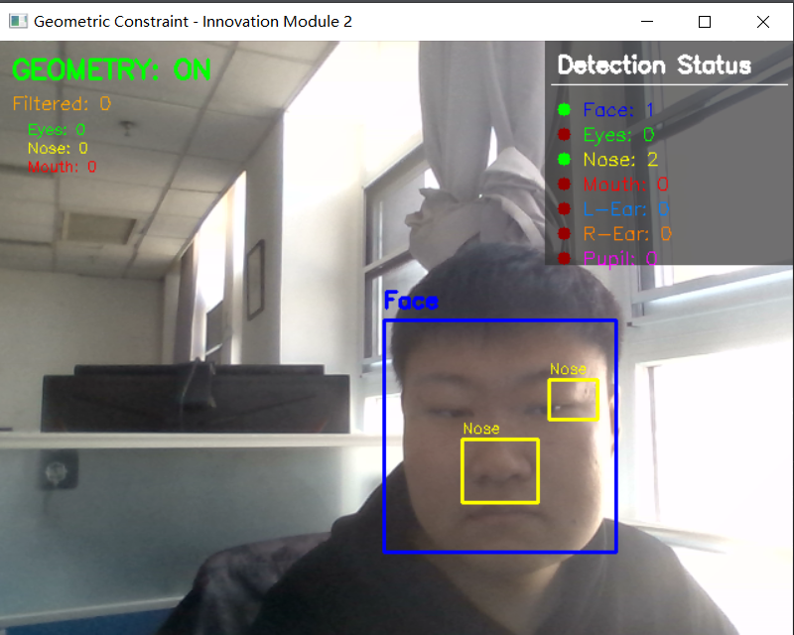

能看出关闭时，将鼻子识别为嘴的概率很大

**2.3 隐私马赛克盾**

本模块实现实时人脸马赛克效果。在新闻报道、监控回放等场景中，常需要保护个人隐私。

马赛克效果通过降采样+升采样实现：

**原图ROI → 降采样(1/15) → 最近邻插值升采样 → 方块效果**

实现效果如下：

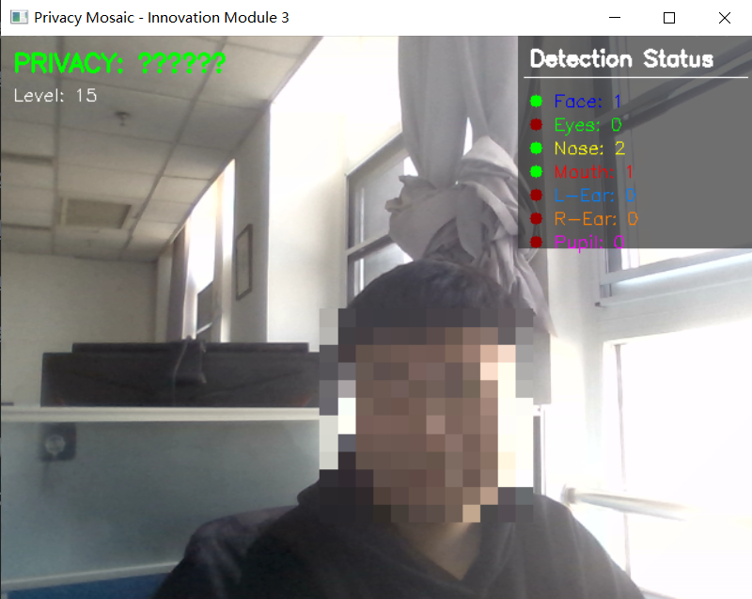

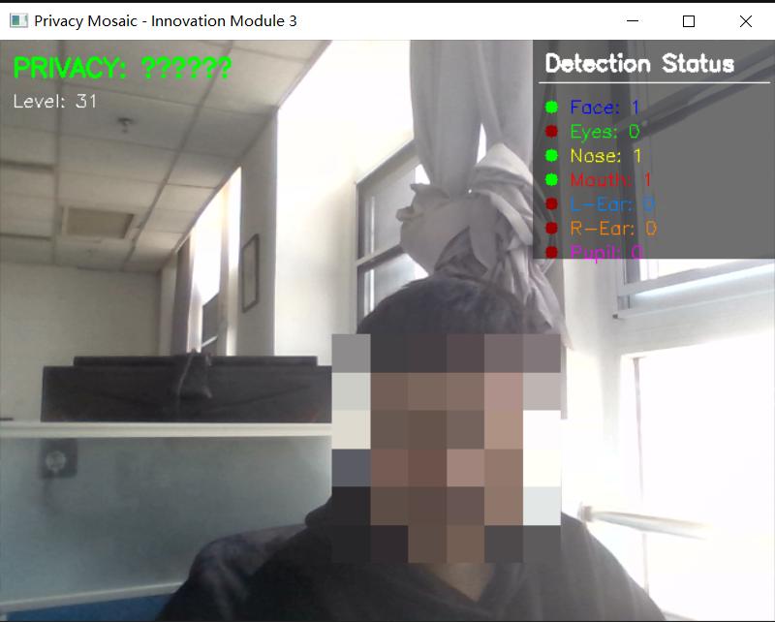

**3 附录**

**3.1 Baseline.py**

|  |
| --- |
| """  数字图像处理作业2：人体部件检测与增强现实系统  基线系统 - 人脸及器官检测模块  """    **import** cv2  **import** numpy as np  **import** os    # ======================== 配置 ========================  CASCADE_DIR **=** os.path.join(os.path.dirname(__file__), "cascade_files")    # Haar级联分类器路径  CASCADE_PATHS **=** {      "face": os.path.join(CASCADE_DIR, "haarcascade_frontalface_alt.xml"),      "eye": os.path.join(CASCADE_DIR, "haarcascade_eye.xml"),      "nose": os.path.join(CASCADE_DIR, "haarcascade_mcs_nose.xml"),      "mouth": os.path.join(CASCADE_DIR, "haarcascade_mcs_mouth.xml"),      "left_ear": os.path.join(CASCADE_DIR, "haarcascade_mcs_leftear.xml"),      "right_ear": os.path.join(CASCADE_DIR, "haarcascade_mcs_rightear.xml"),  }      **class** FaceDetector:    **def** __init__(self):          """初始化：加载所有级联分类器"""          self.cascades **=** {}  **for** name, path **in** CASCADE_PATHS.items():  **if** os.path.exists(path):                  self.cascades[name] **=** cv2.CascadeClassifier(path)                  print(f"[INFO] 已加载分类器: {name}")  **else**:                  print(f"[WARNING] 未找到分类器: {path}")    **def** detect_face(self, frame, gray**=**None):  **if** gray **is** None:              gray **=** cv2.cvtColor(frame, cv2.COLOR_BGR2GRAY)    **if** "face" **not** **in** self.cascades:  **return** []            # 使用detectMultiScale进行多尺度检测          faces **=** self.cascades["face"].detectMultiScale(              gray,              scaleFactor**=**1.1,      # 每次图像尺寸减小的比例              minNeighbors**=**5,       # 每个目标至少被检测到的次数              minSize**=**(30, 30),     # 目标的最小尺寸              flags**=**cv2.CASCADE_SCALE_IMAGE          )    **return** faces    **def** detect_eyes(self, frame, face_roi, gray_roi**=**None):  **if** "eye" **not** **in** self.cascades:  **return** []            x, y, w, h **=** face_roi            # 仅在人脸上半部分搜索眼睛(眼睛通常在脸部上半区域)          upper_half_h **=** int(h **\*** 0.6)    **if** gray_roi **is** None:              gray **=** cv2.cvtColor(frame, cv2.COLOR_BGR2GRAY)              gray_roi **=** gray[y:y**+**upper_half_h, x:x**+**w]  **else**:              gray_roi **=** gray_roi[:upper_half_h, :]            eyes_local **=** self.cascades["eye"].detectMultiScale(              gray_roi,              scaleFactor**=**1.1,              minNeighbors**=**5,              minSize**=**(20, 20)          )            # 转换为原图坐标          eyes **=** []  **for** (ex, ey, ew, eh) **in** eyes_local:              eyes.append((x **+** ex, y **+** ey, ew, eh))    **return** eyes    **def** detect_nose(self, frame, face_roi, gray_roi**=**None):  **if** "nose" **not** **in** self.cascades:  **return** []            x, y, w, h **=** face_roi    **if** gray_roi **is** None:              gray **=** cv2.cvtColor(frame, cv2.COLOR_BGR2GRAY)              gray_roi **=** gray[y:y**+**h, x:x**+**w]            noses_local **=** self.cascades["nose"].detectMultiScale(              gray_roi,              scaleFactor**=**1.1,              minNeighbors**=**5,              minSize**=**(20, 20)          )            # 转换为原图坐标          noses **=** []  **for** (nx, ny, nw, nh) **in** noses_local:              noses.append((x **+** nx, y **+** ny, nw, nh))    **return** noses    **def** detect_mouth(self, frame, face_roi, gray_roi**=**None):  **if** "mouth" **not** **in** self.cascades:  **return** []            x, y, w, h **=** face_roi            # 嘴巴通常在脸部下半部分          lower_start **=** int(h **\*** 0.5)    **if** gray_roi **is** None:              gray **=** cv2.cvtColor(frame, cv2.COLOR_BGR2GRAY)              gray_roi **=** gray[y**+**lower_start:y**+**h, x:x**+**w]  **else**:              gray_roi **=** gray_roi[lower_start:, :]            mouths_local **=** self.cascades["mouth"].detectMultiScale(              gray_roi,              scaleFactor**=**1.1,              minNeighbors**=**10,  # 提高阈值减少误检              minSize**=**(25, 15)          )            # 转换为原图坐标          mouths **=** []  **for** (mx, my, mw, mh) **in** mouths_local:              mouths.append((x **+** mx, y **+** lower_start **+** my, mw, mh))    **return** mouths    **def** detect_ears(self, frame, face_roi, gray_roi**=**None):          x, y, w, h **=** face_roi    **if** gray_roi **is** None:              gray **=** cv2.cvtColor(frame, cv2.COLOR_BGR2GRAY)              gray_roi **=** gray[y:y**+**h, x:x**+**w]            ears **=** {"left": [], "right": []}            # 左耳(通常在图像右侧)  **if** "left_ear" **in** self.cascades:              left_ears **=** self.cascades["left_ear"].detectMultiScale(                  gray_roi,                  scaleFactor**=**1.1,                  minNeighbors**=**3,                  minSize**=**(15, 25)              )  **for** (ex, ey, ew, eh) **in** left_ears:                  ears["left"].append((x **+** ex, y **+** ey, ew, eh))            # 右耳(通常在图像左侧)  **if** "right_ear" **in** self.cascades:              right_ears **=** self.cascades["right_ear"].detectMultiScale(                  gray_roi,                  scaleFactor**=**1.1,                  minNeighbors**=**3,                  minSize**=**(15, 25)              )  **for** (ex, ey, ew, eh) **in** right_ears:                  ears["right"].append((x **+** ex, y **+** ey, ew, eh))    **return** ears    **def** detect_ears_global(self, frame, gray**=**None):    **if** gray **is** None:              gray **=** cv2.cvtColor(frame, cv2.COLOR_BGR2GRAY)            # 直方图均衡化增强对比度          gray **=** cv2.equalizeHist(gray)            ears **=** {"left": [], "right": []}            # 左耳检测 - 降低阈值提高检测率  **if** "left_ear" **in** self.cascades:              left_ears **=** self.cascades["left_ear"].detectMultiScale(                  gray,                  scaleFactor**=**1.05,    # 更小的缩放比例，更精细的搜索                  minNeighbors**=**1,      # 降低阈值                  minSize**=**(15, 20)     # 更小的最小尺寸              )  **for** (ex, ey, ew, eh) **in** left_ears:                  ears["left"].append((ex, ey, ew, eh))            # 右耳检测 - 降低阈值提高检测率  **if** "right_ear" **in** self.cascades:              right_ears **=** self.cascades["right_ear"].detectMultiScale(                  gray,                  scaleFactor**=**1.05,                  minNeighbors**=**1,                  minSize**=**(15, 20)              )  **for** (ex, ey, ew, eh) **in** right_ears:                  ears["right"].append((ex, ey, ew, eh))    **return** ears    **def** detect_pupil(self, eye_roi):  **if** eye_roi **is** None **or** eye_roi.size **==** 0:  **return** None            # 检查图像尺寸是否太小  **if** eye_roi.shape[0] < 10 **or** eye_roi.shape[1] < 10:  **return** None            # 转为灰度  **if** len(eye_roi.shape) **==** 3:              gray **=** cv2.cvtColor(eye_roi, cv2.COLOR_BGR2GRAY)  **else**:              gray **=** eye_roi.copy()            # 高斯模糊去噪（减小核大小以保留更多细节）          blurred **=** cv2.GaussianBlur(gray, (5, 5), 0)            # 图像反相 - 使黑色瞳孔变为白色高亮          inverted **=** cv2.bitwise_not(blurred)            # 使用自适应阈值或降低固定阈值          # 方法1：降低阈值（原来200太高）          _, thresh **=** cv2.threshold(inverted, 120, 255, cv2.THRESH_BINARY)            # 形态学操作去除噪点          kernel **=** cv2.getStructuringElement(cv2.MORPH_ELLIPSE, (3, 3))          thresh **=** cv2.morphologyEx(thresh, cv2.MORPH_OPEN, kernel)          thresh **=** cv2.morphologyEx(thresh, cv2.MORPH_CLOSE, kernel)            # 查找轮廓          contours, _ **=** cv2.findContours(thresh, cv2.RETR_EXTERNAL, cv2.CHAIN_APPROX_SIMPLE)    **if** **not** contours:  **return** None            # 几何筛选 - 寻找最接近圆形的轮廓          best_pupil **=** None          best_score **=** 0            roi_h, roi_w **=** gray.shape[:2]          roi_area **=** roi_h **\*** roi_w          roi_center_x **=** roi_w **//** 2          roi_center_y **=** roi_h **//** 2    **for** contour **in** contours:              area **=** cv2.contourArea(contour)                # 放宽面积约束  **if** area < roi_area **\*** 0.005 **or** area > roi_area **\*** 0.6:  **continue**                perimeter **=** cv2.arcLength(contour, True)  **if** perimeter **==** 0:  **continue**                # 圆形度计算              circularity **=** 4 **\*** np.pi **\*** area **/** (perimeter **\*\*** 2)                # 放宽圆形度约束（从0.3降到0.2）  **if** circularity < 0.2:  **continue**                # 计算轮廓中心              M **=** cv2.moments(contour)  **if** M["m00"] **==** 0:  **continue**              cx **=** int(M["m10"] **/** M["m00"])              cy **=** int(M["m01"] **/** M["m00"])                # 优先选择靠近眼睛中心的轮廓              dist_to_center **=** np.sqrt((cx **-** roi_center_x)**\*\***2 **+** (cy **-** roi_center_y)**\*\***2)              max_dist **=** np.sqrt(roi_center_x**\*\***2 **+** roi_center_y**\*\***2)              center_score **=** 1 **-** (dist_to_center **/** max_dist) **if** max_dist > 0 **else** 0                # 综合评分：圆形度 + 中心距离              score **=** circularity **\*** 0.5 **+** center_score **\*** 0.5    **if** score > best_score:                  best_score **=** score                  (cx, cy), radius **=** cv2.minEnclosingCircle(contour)                  best_pupil **=** (int(cx), int(cy), max(2, int(radius)))    **return** best_pupil      **def** draw_detections(frame, faces, detector, draw_config**=**None):  **if** draw_config **is** None:          draw_config **=** {              "face": True,              "eyes": True,              "nose": True,              "mouth": True,              "ears": True,              "pupil": True          }        # 检测统计      stats **=** {          "face": len(faces),          "eyes": 0,          "nose": 0,          "mouth": 0,          "left_ear": 0,          "right_ear": 0,          "pupil": 0      }        gray **=** cv2.cvtColor(frame, cv2.COLOR_BGR2GRAY)    **for** (x, y, w, h) **in** faces:          # 绘制人脸框  **if** draw_config.get("face", True):              cv2.rectangle(frame, (x, y), (x**+**w, y**+**h), (255, 0, 0), 2)              cv2.putText(frame, "Face", (x, y**-**10),                         cv2.FONT_HERSHEY_SIMPLEX, 0.6, (255, 0, 0), 2)            face_roi **=** (x, y, w, h)          gray_face **=** gray[y:y**+**h, x:x**+**w]            # 检测并绘制眼睛  **if** draw_config.get("eyes", True):              eyes **=** detector.detect_eyes(frame, face_roi, gray_face.copy())              stats["eyes"] **+=** len(eyes)  **for** (ex, ey, ew, eh) **in** eyes:                  cv2.rectangle(frame, (ex, ey), (ex**+**ew, ey**+**eh), (0, 255, 0), 2)                  cv2.putText(frame, "Eye", (ex, ey**-**5),                             cv2.FONT_HERSHEY_SIMPLEX, 0.4, (0, 255, 0), 1)                    # 瞳孔检测  **if** draw_config.get("pupil", True):                      eye_img **=** frame[ey:ey**+**eh, ex:ex**+**ew]                      pupil **=** detector.detect_pupil(eye_img)  **if** pupil:                          stats["pupil"] **+=** 1                          px, py, pr **=** pupil                          # 转换到原图坐标                          cv2.circle(frame, (ex**+**px, ey**+**py), pr, (255, 0, 255), 2)                          cv2.circle(frame, (ex**+**px, ey**+**py), 2, (255, 0, 255), **-**1)            # 检测并绘制鼻子  **if** draw_config.get("nose", True):              noses **=** detector.detect_nose(frame, face_roi, gray_face.copy())              stats["nose"] **+=** len(noses)  **for** (nx, ny, nw, nh) **in** noses:                  cv2.rectangle(frame, (nx, ny), (nx**+**nw, ny**+**nh), (0, 255, 255), 2)                  cv2.putText(frame, "Nose", (nx, ny**-**5),                             cv2.FONT_HERSHEY_SIMPLEX, 0.4, (0, 255, 255), 1)            # 检测并绘制嘴巴  **if** draw_config.get("mouth", True):              mouths **=** detector.detect_mouth(frame, face_roi, gray_face.copy())              stats["mouth"] **+=** len(mouths)  **for** (mx, my, mw, mh) **in** mouths:                  cv2.rectangle(frame, (mx, my), (mx**+**mw, my**+**mh), (0, 0, 255), 2)                  cv2.putText(frame, "Mouth", (mx, my**-**5),                             cv2.FONT_HERSHEY_SIMPLEX, 0.4, (0, 0, 255), 1)            # 检测并绘制耳朵  **if** draw_config.get("ears", True):              ears **=** detector.detect_ears(frame, face_roi, gray_face.copy())              stats["left_ear"] **+=** len(ears["left"])              stats["right_ear"] **+=** len(ears["right"])  **for** ear **in** ears["left"]:                  ex, ey, ew, eh **=** ear                  cv2.rectangle(frame, (ex, ey), (ex**+**ew, ey**+**eh), (255, 128, 0), 2)                  cv2.putText(frame, "L-Ear", (ex, ey**-**5),                             cv2.FONT_HERSHEY_SIMPLEX, 0.4, (255, 128, 0), 1)  **for** ear **in** ears["right"]:                  ex, ey, ew, eh **=** ear                  cv2.rectangle(frame, (ex, ey), (ex**+**ew, ey**+**eh), (0, 128, 255), 2)                  cv2.putText(frame, "R-Ear", (ex, ey**-**5),                             cv2.FONT_HERSHEY_SIMPLEX, 0.4, (0, 128, 255), 1)        # 当没有检测到人脸时，进行全局耳朵检测（侧脸场景）  **if** len(faces) **==** 0 **and** draw_config.get("ears", True):          ears **=** detector.detect_ears_global(frame, gray)          stats["left_ear"] **+=** len(ears["left"])          stats["right_ear"] **+=** len(ears["right"])  **for** ear **in** ears["left"]:              ex, ey, ew, eh **=** ear              cv2.rectangle(frame, (ex, ey), (ex**+**ew, ey**+**eh), (255, 128, 0), 2)              cv2.putText(frame, "L-Ear", (ex, ey**-**5),                         cv2.FONT_HERSHEY_SIMPLEX, 0.4, (255, 128, 0), 1)  **for** ear **in** ears["right"]:              ex, ey, ew, eh **=** ear              cv2.rectangle(frame, (ex, ey), (ex**+**ew, ey**+**eh), (0, 128, 255), 2)              cv2.putText(frame, "R-Ear", (ex, ey**-**5),                         cv2.FONT_HERSHEY_SIMPLEX, 0.4, (0, 128, 255), 1)    **return** frame, stats      **def** draw_status_panel(frame, stats):      """      在图像上绘制检测状态面板        Args:          frame: BGR图像          stats: 检测统计字典        Returns:          frame: 绘制后的图像      """      h, w **=** frame.shape[:2]        # 状态面板背景      panel_h **=** 180      overlay **=** frame.copy()      cv2.rectangle(overlay, (w**-**200, 0), (w, panel_h), (50, 50, 50), **-**1)      cv2.addWeighted(overlay, 0.7, frame, 0.3, 0, frame)        # 标题      cv2.putText(frame, "Detection Status", (w**-**190, 25),                 cv2.FONT_HERSHEY_SIMPLEX, 0.6, (255, 255, 255), 2)      cv2.line(frame, (w**-**195, 35), (w**-**5, 35), (255, 255, 255), 1)        # 各部位状态      status_items **=** [          ("Face", stats["face"], (255, 0, 0)),          ("Eyes", stats["eyes"], (0, 255, 0)),          ("Nose", stats["nose"], (0, 255, 255)),          ("Mouth", stats["mouth"], (0, 0, 255)),          ("L-Ear", stats["left_ear"], (255, 128, 0)),          ("R-Ear", stats["right_ear"], (0, 128, 255)),          ("Pupil", stats["pupil"], (255, 0, 255)),      ]        y_offset **=** 55  **for** name, count, color **in** status_items:          # 状态指示器 (绿点=检测到, 红点=未检测到)          indicator_color **=** (0, 255, 0) **if** count > 0 **else** (0, 0, 150)          cv2.circle(frame, (w**-**185, y_offset), 5, indicator_color, **-**1)            # 部位名称和数量          text **=** f"{name}: {count}"          cv2.putText(frame, text, (w**-**170, y_offset **+** 5),                     cv2.FONT_HERSHEY_SIMPLEX, 0.5, color, 1)            y_offset **+=** 20    **return** frame      **def** test_with_image(image_path):      """使用静态图片测试检测功能"""      print(f"\n[INFO] 使用图片测试模式: {image_path}")        detector **=** FaceDetector()        frame **=** cv2.imread(image_path)  **if** frame **is** None:          print(f"[ERROR] 无法读取图片: {image_path}")  **return**        gray **=** cv2.cvtColor(frame, cv2.COLOR_BGR2GRAY)      faces **=** detector.detect_face(frame, gray)        print(f"[INFO] 检测到 {len(faces)} 张人脸")        frame, stats **=** draw_detections(frame, faces, detector)      frame **=** draw_status_panel(frame, stats)        # 打印检测统计      print("\n[检测统计]")      print(f"  Face: {stats['face']}")      print(f"  Eyes: {stats['eyes']}")      print(f"  Nose: {stats['nose']}")      print(f"  Mouth: {stats['mouth']}")      print(f"  L-Ear: {stats['left_ear']}")      print(f"  R-Ear: {stats['right_ear']}")      print(f"  Pupil: {stats['pupil']}")        # 显示结果      cv2.imshow("Face Detection - Image Test", frame)      print("[INFO] 按任意键保存并退出...")      cv2.waitKey(0)        # 保存结果      output_path **=** image_path.replace(".", "_result.")      cv2.imwrite(output_path, frame)      print(f"[INFO] 结果已保存: {output_path}")        cv2.destroyAllWindows()      **def** main():      """主函数 - 实时摄像头检测演示"""      print("=" **\*** 50)      print("数字图像处理作业2 - 人体部件检测系统(基线)")      print("=" **\*** 50)        # 初始化检测器      detector **=** FaceDetector()        # 尝试使用DirectShow后端打开摄像头(Windows专用,更稳定)      print("\n[INFO] 尝试使用DirectShow后端打开摄像头...")      cap **=** cv2.VideoCapture(0, cv2.CAP_DSHOW)    **if** **not** cap.isOpened():          print("[WARNING] DirectShow失败,尝试默认后端...")          cap **=** cv2.VideoCapture(0)    **if** **not** cap.isOpened():          print("[ERROR] 无法打开摄像头!")          print("[TIP] 请检查摄像头是否被其他程序占用")          print("[TIP] 或使用图片测试模式: python face_detector.py --image <图片路径>")  **return**        # 设置摄像头参数      cap.set(cv2.CAP_PROP_FRAME_WIDTH, 640)      cap.set(cv2.CAP_PROP_FRAME_HEIGHT, 480)        print("\n[INFO] 摄像头已开启")      print("[INFO] 按 'q' 退出程序")      print("[INFO] 按 's' 保存当前帧截图")        frame_count **=** 0      fail_count **=** 0      max_fails **=** 10    **while** True:          ret, frame **=** cap.read()  **if** **not** ret:              fail_count **+=** 1              print(f"[WARNING] 读取帧失败 ({fail_count}/{max_fails})")  **if** fail_count >**=** max_fails:                  print("[ERROR] 连续读取失败,退出程序!")  **break**  **continue**            fail_count **=** 0  # 重置失败计数            # 水平翻转(镜像效果更自然)          frame **=** cv2.flip(frame, 1)            # 转换为灰度图          gray **=** cv2.cvtColor(frame, cv2.COLOR_BGR2GRAY)            # 检测人脸          faces **=** detector.detect_face(frame, gray)            # 绘制所有检测结果          frame, stats **=** draw_detections(frame, faces, detector)            # 绘制状态面板          frame **=** draw_status_panel(frame, stats)            # 显示结果          cv2.imshow("Face Detection - Baseline", frame)            # 键盘事件处理          key **=** cv2.waitKey(1) & 0xFF  **if** key **==** ord('q'):  **break**  **elif** key **==** ord('s'):              filename **=** f"screenshot_{frame_count}.png"              cv2.imwrite(filename, frame)              print(f"[INFO] 截图已保存: {filename}")              frame_count **+=** 1        # 释放资源      cap.release()      cv2.destroyAllWindows()      print("\n[INFO] 程序已退出")      **if** __name__ **==** "__main__":  **import** sys    **if** len(sys.argv) > 2 **and** sys.argv[1] **==** "--image":          # 图片测试模式          test_with_image(sys.argv[2])  **else**:          # 摄像头模式          main() |

**3.2 ar_mask.py**

|  |
| --- |
| **import** cv2  **import** numpy as np  **import** os    # 导入基线检测器  **from** baseline **import** FaceDetector, draw_status_panel    # ======================== 配置 ========================  MASK_DIR **=** os.path.join(os.path.dirname(__file__), "Face")      **class** ARMaskApplier:    **def** __init__(self):          """初始化：加载所有可用面具"""          self.masks **=** []          self.mask_names **=** []          self.current_mask_idx **=** 0            # 加载Face目录下所有图片作为面具  **if** os.path.exists(MASK_DIR):  **for** filename **in** sorted(os.listdir(MASK_DIR)):  **if** filename.lower().endswith(('.jpg', '.jpeg', '.png', '.bmp')):                      mask_path **=** os.path.join(MASK_DIR, filename)                      mask_img **=** cv2.imread(mask_path, cv2.IMREAD_UNCHANGED)  **if** mask_img **is** **not** None:                          self.masks.append(mask_img)                          self.mask_names.append(filename)                          print(f"[INFO] 已加载面具: {filename}")    **if** len(self.masks) **==** 0:              print("[WARNING] 未找到面具图片，请在 Face/ 目录下放置面具图片")    **def** switch_mask(self):          """切换到下一个面具"""  **if** len(self.masks) > 0:              self.current_mask_idx **=** (self.current_mask_idx **+** 1) **%** len(self.masks)              print(f"[INFO] 切换面具: {self.mask_names[self.current_mask_idx]}")    **def** get_current_mask(self):          """获取当前面具"""  **if** len(self.masks) > 0:  **return** self.masks[self.current_mask_idx]  **return** None    **def** apply_mask(self, frame, face_roi):          mask_img **=** self.get_current_mask()  **if** mask_img **is** None:  **return** frame            x, y, w, h **=** face_roi            # 确保坐标有效  **if** x < 0 **or** y < 0 **or** x**+**w > frame.shape[1] **or** y**+**h > frame.shape[0]:  **return** frame    **try**:              # 1. 将面具缩放到人脸大小              mask_resized **=** cv2.resize(mask_img, (w, h), interpolation**=**cv2.INTER_AREA)                # 2. 检查面具是否有Alpha通道  **if** mask_resized.shape[2] **==** 4:                  # 有Alpha通道的情况（PNG透明图）                  alpha **=** mask_resized[:, :, 3] **/** 255.0                  mask_bgr **=** mask_resized[:, :, :3]  **else**:                  # 无Alpha通道，使用颜色阈值生成掩膜                  # 假设白色或接近白色为背景                  mask_gray **=** cv2.cvtColor(mask_resized, cv2.COLOR_BGR2GRAY)                  _, binary_mask **=** cv2.threshold(mask_gray, 240, 255, cv2.THRESH_BINARY_INV)                  alpha **=** binary_mask **/** 255.0                  mask_bgr **=** mask_resized                # 3. 获取人脸ROI              roi **=** frame[y:y**+**h, x:x**+**w]                # 4. Alpha混合              # 公式: output = alpha * mask + (1-alpha) * background  **for** c **in** range(3):                  roi[:, :, c] **=** (alpha **\*** mask_bgr[:, :, c] **+**                                 (1 **-** alpha) **\*** roi[:, :, c]).astype(np.uint8)                # 5. 将处理后的ROI放回原图              frame[y:y**+**h, x:x**+**w] **=** roi    **except** Exception as e:              print(f"[ERROR] 面具应用失败: {e}")    **return** frame    **def** apply_mask_bitwise(self, frame, face_roi, scale**=**1.15, y_offset_ratio**=-**0.1):          mask_img **=** self.get_current_mask()  **if** mask_img **is** None:  **return** frame            x, y, w, h **=** face_roi            # 计算放大后的面具尺寸          new_w **=** int(w **\*** scale)          new_h **=** int(h **\*** scale)            # 计算新的位置（居中并向上偏移）          new_x **=** x **-** (new_w **-** w) **//** 2          new_y **=** y **-** (new_h **-** h) **//** 2 **+** int(h **\*** y_offset_ratio)            # 边界检查和裁剪          frame_h, frame_w **=** frame.shape[:2]            # 计算有效区域          src_x1 **=** max(0, **-**new_x)          src_y1 **=** max(0, **-**new_y)          src_x2 **=** min(new_w, frame_w **-** new_x)          src_y2 **=** min(new_h, frame_h **-** new_y)            dst_x1 **=** max(0, new_x)          dst_y1 **=** max(0, new_y)          dst_x2 **=** min(frame_w, new_x **+** new_w)          dst_y2 **=** min(frame_h, new_y **+** new_h)            # 检查有效性  **if** src_x2 <**=** src_x1 **or** src_y2 <**=** src_y1:  **return** frame    **try**:              # 1. 将面具缩放到放大后的尺寸              mask_resized **=** cv2.resize(mask_img, (new_w, new_h), interpolation**=**cv2.INTER_AREA)                # 2. 裁剪面具到有效区域              mask_cropped **=** mask_resized[src_y1:src_y2, src_x1:src_x2]                # 如果有Alpha通道，转为3通道  **if** mask_cropped.shape[2] **==** 4:                  mask_bgr **=** mask_cropped[:, :, :3]                  alpha_channel **=** mask_cropped[:, :, 3]  **else**:                  mask_bgr **=** mask_cropped                  # 创建掩膜：非白色区域为前景                  mask_gray **=** cv2.cvtColor(mask_bgr, cv2.COLOR_BGR2GRAY)                  _, alpha_channel **=** cv2.threshold(mask_gray, 240, 255, cv2.THRESH_BINARY_INV)                # 3. 生成二值掩膜              mask_binary **=** alpha_channel              mask_inv **=** cv2.bitwise_not(mask_binary)                # 4. 获取目标ROI              roi **=** frame[dst_y1:dst_y2, dst_x1:dst_x2]                # 确保尺寸匹配  **if** roi.shape[:2] !**=** mask_bgr.shape[:2]:  **return** frame                # 5. 使用bitwise_and在ROI中抠出面具形状的黑色区域              roi_bg **=** cv2.bitwise_and(roi, roi, mask**=**mask_inv)                # 6. 使用bitwise_and提取面具的前景部分              mask_fg **=** cv2.bitwise_and(mask_bgr, mask_bgr, mask**=**mask_binary)                # 7. 使用add融合背景和前景              result **=** cv2.add(roi_bg, mask_fg)                # 8. 放回原图              frame[dst_y1:dst_y2, dst_x1:dst_x2] **=** result    **except** Exception as e:              print(f"[ERROR] 面具应用失败: {e}")    **return** frame      **def** draw_detections_with_mask(frame, faces, detector, mask_applier, mask_enabled**=**True):      stats **=** {          "face": len(faces),          "eyes": 0,          "nose": 0,          "mouth": 0,          "left_ear": 0,          "right_ear": 0,          "pupil": 0      }        gray **=** cv2.cvtColor(frame, cv2.COLOR_BGR2GRAY)    **for** (x, y, w, h) **in** faces:          face_roi **=** (x, y, w, h)            # 应用面具  **if** mask_enabled **and** mask_applier **is** **not** None:              frame **=** mask_applier.apply_mask_bitwise(frame, face_roi)  **else**:              # 不应用面具时绘制人脸框              cv2.rectangle(frame, (x, y), (x**+**w, y**+**h), (255, 0, 0), 2)              cv2.putText(frame, "Face", (x, y**-**10),                         cv2.FONT_HERSHEY_SIMPLEX, 0.6, (255, 0, 0), 2)            # 检测其他器官（即使戴了面具也可以检测，用于统计）          gray_face **=** gray[y:y**+**h, x:x**+**w]            eyes **=** detector.detect_eyes(frame, face_roi, gray_face.copy())          stats["eyes"] **+=** len(eyes)            noses **=** detector.detect_nose(frame, face_roi, gray_face.copy())          stats["nose"] **+=** len(noses)            mouths **=** detector.detect_mouth(frame, face_roi, gray_face.copy())          stats["mouth"] **+=** len(mouths)            ears **=** detector.detect_ears(frame, face_roi, gray_face.copy())          stats["left_ear"] **+=** len(ears["left"])          stats["right_ear"] **+=** len(ears["right"])    **return** frame, stats      **def** main():      """主函数 - AR面具演示"""      print("=" **\*** 50)      print("数字图像处理作业2 - 创新模块1：AR面具系统")      print("=" **\*** 50)        # 初始化检测器和面具应用器      detector **=** FaceDetector()      mask_applier **=** ARMaskApplier()        # 打开摄像头      print("\n[INFO] 尝试打开摄像头...")      cap **=** cv2.VideoCapture(0, cv2.CAP_DSHOW)    **if** **not** cap.isOpened():          cap **=** cv2.VideoCapture(0)    **if** **not** cap.isOpened():          print("[ERROR] 无法打开摄像头!")  **return**        cap.set(cv2.CAP_PROP_FRAME_WIDTH, 640)      cap.set(cv2.CAP_PROP_FRAME_HEIGHT, 480)        print("\n[INFO] 摄像头已开启")      print("[INFO] 按键说明：")      print("  [m] - 开关面具模式")      print("  [n] - 切换下一个面具")      print("  [s] - 保存截图")      print("  [q] - 退出程序")        mask_enabled **=** True      frame_count **=** 0    **while** True:          ret, frame **=** cap.read()  **if** **not** ret:  **continue**            # 水平翻转          frame **=** cv2.flip(frame, 1)            # 检测人脸          gray **=** cv2.cvtColor(frame, cv2.COLOR_BGR2GRAY)          faces **=** detector.detect_face(frame, gray)            # 绘制检测结果（可选面具）          frame, stats **=** draw_detections_with_mask(              frame, faces, detector, mask_applier, mask_enabled          )            # 绘制状态面板          frame **=** draw_status_panel(frame, stats)            # 绘制模式提示          mode_text **=** "MASK: ON" **if** mask_enabled **else** "MASK: OFF"          mode_color **=** (0, 255, 0) **if** mask_enabled **else** (0, 0, 255)          cv2.putText(frame, mode_text, (10, 30),                     cv2.FONT_HERSHEY_SIMPLEX, 0.7, mode_color, 2)    **if** mask_enabled **and** len(mask_applier.mask_names) > 0:              mask_text **=** f"Current: {mask_applier.mask_names[mask_applier.current_mask_idx]}"              cv2.putText(frame, mask_text, (10, 55),                         cv2.FONT_HERSHEY_SIMPLEX, 0.5, (255, 255, 255), 1)            # 显示结果          cv2.imshow("AR Mask - Innovation Module 1", frame)            # 键盘事件          key **=** cv2.waitKey(1) & 0xFF  **if** key **==** ord('q'):  **break**  **elif** key **==** ord('m'):              mask_enabled **=** **not** mask_enabled              print(f"[INFO] 面具模式: {'开启' if mask_enabled else '关闭'}")  **elif** key **==** ord('n'):              mask_applier.switch_mask()  **elif** key **==** ord('s'):              filename **=** f"ar_mask_screenshot_{frame_count}.png"              cv2.imwrite(filename, frame)              print(f"[INFO] 截图已保存: {filename}")              frame_count **+=** 1        cap.release()      cv2.destroyAllWindows()      print("\n[INFO] 程序已退出")      **if** __name__ **==** "__main__":      main() |

**3.3 privacy_mosaic.py**

|  |
| --- |
| **import** cv2  **import** numpy as np  **import** os    # 导入基线检测器  **from** baseline **import** FaceDetector, draw_status_panel      **class** PrivacyMosaic:    **def** __init__(self, default_level**=**15):          """          初始化马赛克处理器            Args:              default_level: 默认马赛克等级（像素块大小）          """          self.level **=** default_level          self.min_level **=** 5          self.max_level **=** 30    **def** increase_level(self):          """增加马赛克强度（更模糊）"""  **if** self.level < self.max_level:              self.level **+=** 2              print(f"[INFO] 马赛克等级: {self.level}")    **def** decrease_level(self):          """降低马赛克强度（更清晰）"""  **if** self.level > self.min_level:              self.level **-=** 2              print(f"[INFO] 马赛克等级: {self.level}")    **def** apply_mosaic(self, frame, roi_rect):          x, y, w, h **=** roi_rect            # 边界检查          frame_h, frame_w **=** frame.shape[:2]          x **=** max(0, x)          y **=** max(0, y)          w **=** min(w, frame_w **-** x)          h **=** min(h, frame_h **-** y)    **if** w <**=** 0 **or** h <**=** 0:  **return** frame    **try**:              # 1. 提取ROI              roi **=** frame[y:y**+**h, x:x**+**w]                # 2. 计算缩小后的尺寸              small_w **=** max(1, w **//** self.level)              small_h **=** max(1, h **//** self.level)                # 3. 降采样（使用INTER_LINEAR平滑采样）              small **=** cv2.resize(roi, (small_w, small_h), interpolation**=**cv2.INTER_LINEAR)                # 4. 升采样（使用INTER_NEAREST最近邻插值，产生方块效果）              mosaic **=** cv2.resize(small, (w, h), interpolation**=**cv2.INTER_NEAREST)                # 5. 放回原图              frame[y:y**+**h, x:x**+**w] **=** mosaic    **except** Exception as e:              print(f"[ERROR] 马赛克应用失败: {e}")    **return** frame    **def** apply_mosaic_face(self, frame, face_rect, expand_ratio**=**0.1):          x, y, w, h **=** face_rect            # 扩展区域          expand_w **=** int(w **\*** expand_ratio)          expand_h **=** int(h **\*** expand_ratio)            new_x **=** x **-** expand_w          new_y **=** y **-** expand_h          new_w **=** w **+** 2 **\*** expand_w          new_h **=** h **+** 2 **\*** expand_h    **return** self.apply_mosaic(frame, (new_x, new_y, new_w, new_h))    **def** apply_mosaic_eyes(self, frame, eye_rects, expand_ratio**=**0.3):  **for** (ex, ey, ew, eh) **in** eye_rects:              # 扩展眼睛区域              expand_w **=** int(ew **\*** expand_ratio)              expand_h **=** int(eh **\*** expand_ratio)                new_x **=** ex **-** expand_w              new_y **=** ey **-** expand_h              new_w **=** ew **+** 2 **\*** expand_w              new_h **=** eh **+** 2 **\*** expand_h                frame **=** self.apply_mosaic(frame, (new_x, new_y, new_w, new_h))    **return** frame      **def** draw_detections_with_mosaic(frame, faces, detector, mosaic_processor,                                   mosaic_mode**=**"off"):      stats **=** {          "face": len(faces),          "eyes": 0,          "nose": 0,          "mouth": 0,          "left_ear": 0,          "right_ear": 0,          "pupil": 0      }        gray **=** cv2.cvtColor(frame, cv2.COLOR_BGR2GRAY)    **for** (x, y, w, h) **in** faces:          face_roi **=** (x, y, w, h)          gray_face **=** gray[y:y**+**h, x:x**+**w]            # 检测眼睛（用于eyes模式和统计）          eyes **=** detector.detect_eyes(frame, face_roi, gray_face.copy())          stats["eyes"] **+=** len(eyes)            # 应用马赛克  **if** mosaic_mode **==** "face":              # 整脸马赛克              frame **=** mosaic_processor.apply_mosaic_face(frame, face_roi)  **elif** mosaic_mode **==** "eyes":              # 仅眼睛马赛克              frame **=** mosaic_processor.apply_mosaic_eyes(frame, eyes)              # 绘制人脸框（眼睛模式下显示人脸框）              cv2.rectangle(frame, (x, y), (x**+**w, y**+**h), (255, 0, 0), 2)  **else**:              # 正常模式：绘制所有检测框              cv2.rectangle(frame, (x, y), (x**+**w, y**+**h), (255, 0, 0), 2)              cv2.putText(frame, "Face", (x, y**-**10),                         cv2.FONT_HERSHEY_SIMPLEX, 0.6, (255, 0, 0), 2)                # 绘制眼睛  **for** (ex, ey, ew, eh) **in** eyes:                  cv2.rectangle(frame, (ex, ey), (ex**+**ew, ey**+**eh), (0, 255, 0), 2)            # 其他器官检测（用于统计）          noses **=** detector.detect_nose(frame, face_roi, gray_face.copy())          stats["nose"] **+=** len(noses)            mouths **=** detector.detect_mouth(frame, face_roi, gray_face.copy())          stats["mouth"] **+=** len(mouths)            ears **=** detector.detect_ears(frame, face_roi, gray_face.copy())          stats["left_ear"] **+=** len(ears["left"])          stats["right_ear"] **+=** len(ears["right"])    **return** frame, stats      **def** main():      """主函数 - 隐私马赛克演示"""      print("=" **\*** 50)      print("数字图像处理作业2 - 创新模块3：隐私马赛克盾")      print("=" **\*** 50)        # 初始化      detector **=** FaceDetector()      mosaic_processor **=** PrivacyMosaic(default_level**=**15)        # 打开摄像头      print("\n[INFO] 尝试打开摄像头...")      cap **=** cv2.VideoCapture(0, cv2.CAP_DSHOW)    **if** **not** cap.isOpened():          cap **=** cv2.VideoCapture(0)    **if** **not** cap.isOpened():          print("[ERROR] 无法打开摄像头!")  **return**        cap.set(cv2.CAP_PROP_FRAME_WIDTH, 640)      cap.set(cv2.CAP_PROP_FRAME_HEIGHT, 480)        print("\n[INFO] 摄像头已开启")      print("[INFO] 按键说明：")      print("  [p] - 切换马赛克模式 (关闭 → 整脸 → 仅眼睛)")      print("  [+] - 增加马赛克强度")      print("  [-] - 降低马赛克强度")      print("  [s] - 保存截图")      print("  [q] - 退出程序")        mosaic_modes **=** ["off", "face", "eyes"]      mosaic_mode_names **=** {"off": "关闭", "face": "整脸", "eyes": "仅眼睛"}      current_mode_idx **=** 0      frame_count **=** 0    **while** True:          ret, frame **=** cap.read()  **if** **not** ret:  **continue**            # 水平翻转          frame **=** cv2.flip(frame, 1)            # 检测人脸          gray **=** cv2.cvtColor(frame, cv2.COLOR_BGR2GRAY)          faces **=** detector.detect_face(frame, gray)            # 绘制检测结果（可选马赛克）          current_mode **=** mosaic_modes[current_mode_idx]          frame, stats **=** draw_detections_with_mosaic(              frame, faces, detector, mosaic_processor, current_mode          )            # 绘制状态面板          frame **=** draw_status_panel(frame, stats)            # 绘制模式提示          mode_text **=** f"PRIVACY: {mosaic_mode_names[current_mode]}"          mode_color **=** (0, 255, 0) **if** current_mode !**=** "off" **else** (0, 0, 255)          cv2.putText(frame, mode_text, (10, 30),                     cv2.FONT_HERSHEY_SIMPLEX, 0.7, mode_color, 2)    **if** current_mode !**=** "off":              level_text **=** f"Level: {mosaic_processor.level}"              cv2.putText(frame, level_text, (10, 55),                         cv2.FONT_HERSHEY_SIMPLEX, 0.5, (255, 255, 255), 1)            # 显示结果          cv2.imshow("Privacy Mosaic - Innovation Module 3", frame)            # 键盘事件          key **=** cv2.waitKey(1) & 0xFF  **if** key **==** ord('q'):  **break**  **elif** key **==** ord('p'):              current_mode_idx **=** (current_mode_idx **+** 1) **%** len(mosaic_modes)              print(f"[INFO] 马赛克模式: {mosaic_mode_names[mosaic_modes[current_mode_idx]]}")  **elif** key **==** ord('+') **or** key **==** ord('='):              mosaic_processor.increase_level()  **elif** key **==** ord('-') **or** key **==** ord('_'):              mosaic_processor.decrease_level()  **elif** key **==** ord('s'):              filename **=** f"privacy_screenshot_{frame_count}.png"              cv2.imwrite(filename, frame)              print(f"[INFO] 截图已保存: {filename}")              frame_count **+=** 1        cap.release()      cv2.destroyAllWindows()      print("\n[INFO] 程序已退出")      **if** __name__ **==** "__main__":      main() |